Editorial Highlights
2024-2025

UPFRONT
Keynote
Norwegian Cruise Line Holdings is a highly regarded industry giant with 32 ships in it’s fleet and five more currently on order for delivery by 2028. The company visits approximately 700 destinations globally each year and through Norwegian Cruise Line it has delighted passengers for almost 60 years. In this keynote we explore how their itineraries remain key to delivering an outstanding guest experience.

Marketwatch
An eclectic round-up of the top global port and destination news, views, opinions and insights. We also share a curated collection of enticing destination images that could fill ships full of social media wow-hunters. For our extended story in this issue, we highlight some of the new shore excursion combinations that have been thoughtfully conceived, carefully tested and are now available to woo passengers and give shorex sales a boost.

FEATURES
Feature: Elevating destination appeal
Coastal towns and cities become successful cruise destinations through building their international reputation and appeal with the travel trade, regular cruisers and the new-to-cruise market. In this feature we ask popular, growing and new destinations to articulate the essence of their existing offer and share the plans they have to elevate their appeal for increasingly discerning global travellers.

Roundtable: Perfecting the passenger port experience
Ports must fulfil certain criteria to enable a cruise call and hit a minimum service standard to satisfy operational needs. But passengers are more demanding and expect much closer to perfection through each travel transition, during every personal interaction and with every available facility. In this roundtable we talk to port leaders about the lengths that they go to in order to ensure an entirely positive passenger experience.

MAIDEN SEASON
The carefully curated inaugural voyages and maiden seasons of new cruise ships include calls at ports and destinations that cruise companies are confident will woo the passengers. We review the very different maiden seasons planned for four ships launching in 2024-2025:

Mein Schiff 7: Northern Europe/Baltic  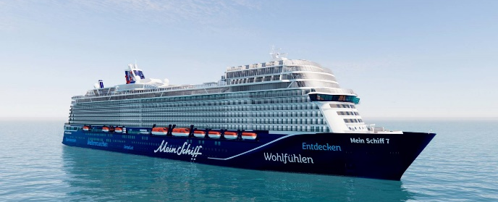 | Norwegian Aqua: Bermuda & Caribbean  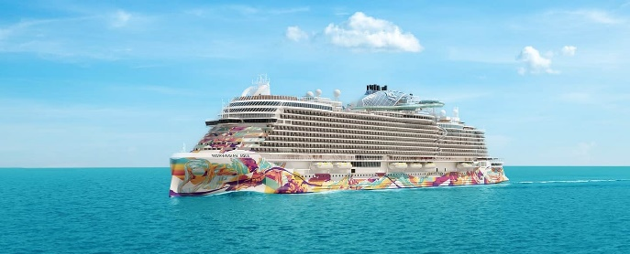
Queen Anne: Northern Europe & Mediterranean  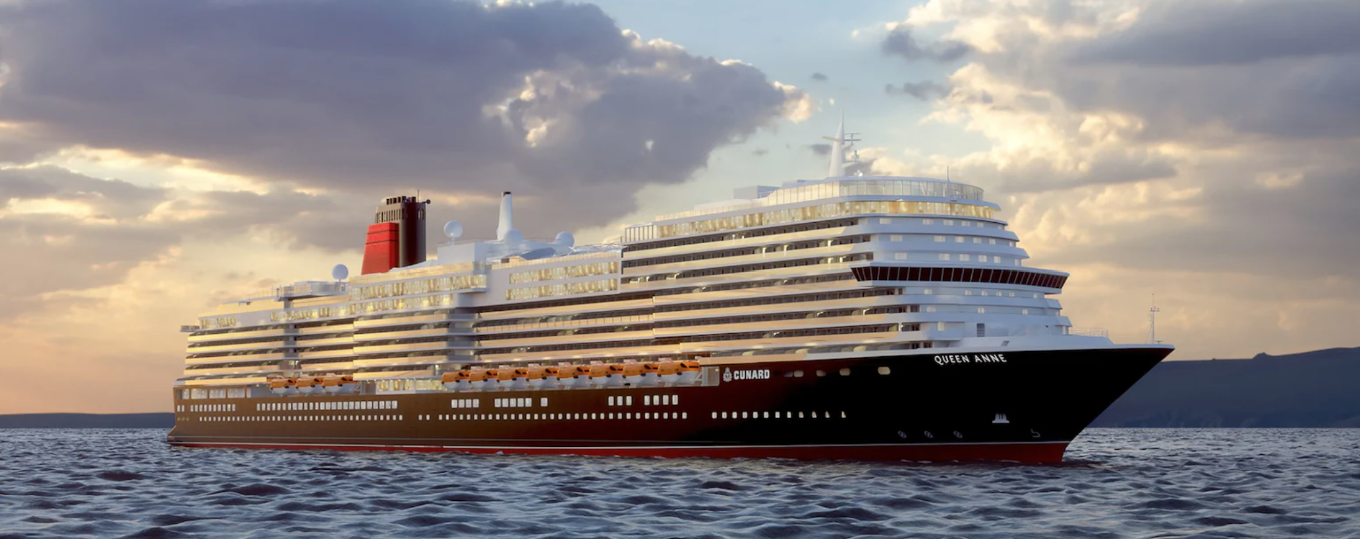 | Ilma: Mediterranean & Caribbean  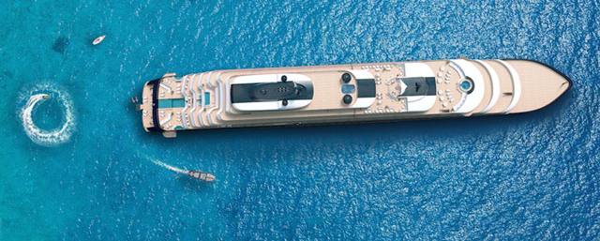
PLANNER PERSPECTIVES
In our 'planner perspective' interviews, cruise executives share their essential knowledge and wisdom about how ports and destinations can improve their offerings for greater levels of passenger satisfaction. We speak with executives from:

- Royal Caribbean Group
- Holland America Line
- Princess Cruises
- Celebrity Cruises
- MSC Cruises
- P&O Cruises

REPORTS
Rebuilding shore excursion sales
Cruise line shore excursion sales have reduced through land-based competition and passengers taking self-guided journeys around destinations. And so while passengers are still happy to pay for authentic destination experiences, how do we reverse the trend so that good shorex sales volumes make a bigger contribution to cruise call profitability? In this report we speak to a selection of leading tour operators to find out what steps they recommend to help rebuild this once thriving revenue stream.

Association highlights
Renowned port and destination associations share their members’ latest news and highlight some of the key initiatives that they are currently developing. Invited contributors include:

- Asia Cruise Terminal Association
- Atlantic Canada Cruise Association
- Australian Cruise Association
- Caribbean Tourism Organization
- Cruise Baltic
- Cruise Europe
- Florida-Caribbean Cruise Association
- MedCruise

Regional spotlight: Caribbean
CFIP talks to leading cruise lines, associations, ports and tourist boards in the Caribbean to get an rounded and up-to-date industry perspective about the rich variety of itineraries that are enchanting cruise passengers from around the world. We explore some of the region’s destination highlights as well as a selection of lesser known, but still highly rated, ports of call.

Featured ports & destinations
Profiles of a series of ports and destinations that are enduringly popular on cruise itineraries:

- North America & Canada
- South America
- Central America & Caribbean
- Northern Europe
- Mediterranean & Black Sea
- Middle East
- Africa, Gulf & Indian Ocean
- Asia Pacific

FURTHER INFORMATION
Partners
Cruise & Ferry is proud to partner with the following organisations:

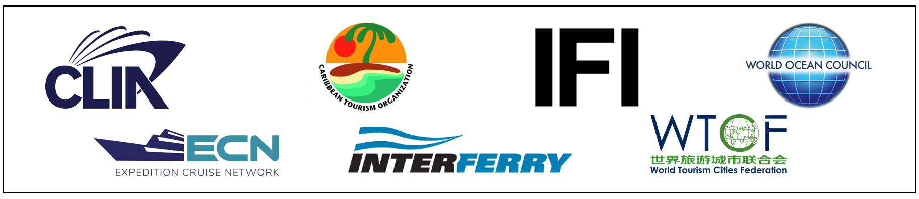

Contacts
Rebecca Gibson, Associate Editor Jon Ingleton, Executive Editor
Email: rebecca.gibson@tudor-rose.co.uk Email: jon.ingleton@tudor-rose.co.uk

This editorial plan is subject to the interview availability of the organisations and individuals listed. Alternative contributors will be found if they are required.

